**EXPERIMENT NO. 1**

TO CONFIGURE AND COMPARE VARIOUS NETWORK TOPOLOGIES USING

CISCO PACKET TRACER

**EXPERIMENT NO. 1**

**AIM**: To Configure and compare various network topologies using cisco packet tracer

**REQUIREMENT**: Cisco packet Tracer

**OBJECTIVE:**

* **Part1:** To configure the following network topologies: Bus, Star, Mesh, Ring, Dual ring and hybrid topology.
* **Part2**: To compare the network topologies

**THEORY**:

**BUS TOPOLOGY:**

In bus topology there is a main cable and all the devices are connected to this main cable through drop lines. There is a device called tap that connects the drop line to the main cable. Since all the data is transmitted over the main cable, there is a limit of drop lines and the distance a main cable can have.

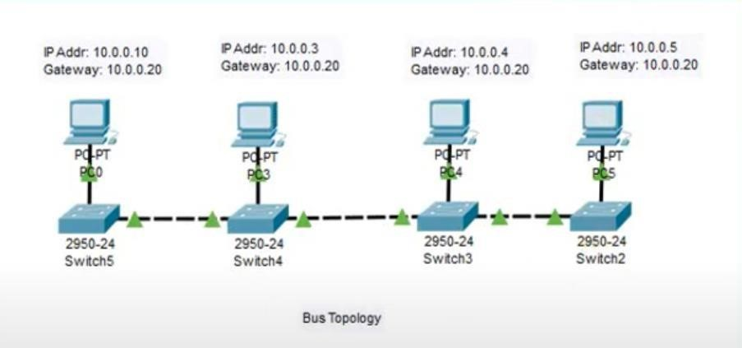

# Advantages of bus topology

1. Easy installation, each cable needs to be connected with backbone cable.
2. Less cables required than Mesh and star topology

# Disadvantages of bus topology

1. .It can be hard to troubleshoot individual device issues.
2. Bus topology is not great for large networks.
3. Terminators are required for both ends of the main cable.
4. Additional devices slow the network down.
5. If a main cable is damaged, the network fails or splits into two.

# STAR TOPOLOGY

In star topology each device in the network is connected to a central device called hub. Unlike Mesh topology, star topology doesn’t allow direct communication between devices, a device must have to communicate through hub. If one device wants to send data to other device, it has to first send the data to hub and then the hub transmit that data to the designated device.

# Advantages of star topology

1. Centralized management of the network, through the use of the central computer, hub, or switch.
2. Easy to add another computer to the network.
3. If one computer on the network fails, the rest of the network continues to function normally.

# Disadvantages of star topology

1. May have a higher cost to implement, especially when using a switch or router as the central network device.
2. The central network device determines the performance and number of nodes the network can handle.
3. If the central computer, hub, or switch fails, the entire network goes down and all computers are disconnected from the network.

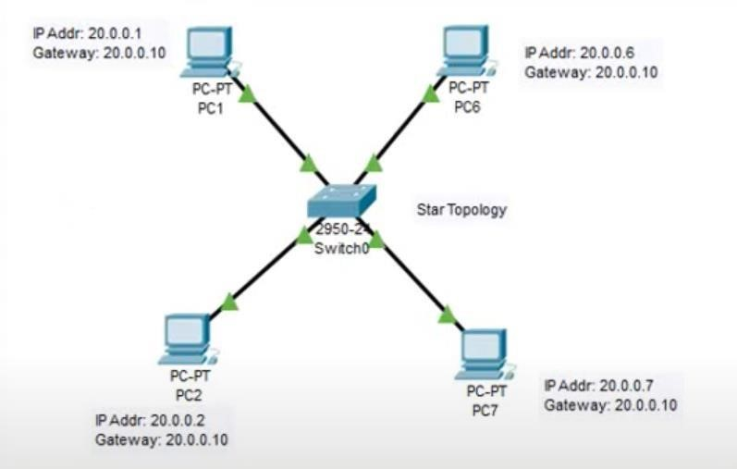

# MESH TOPOLOGY

In mesh topology each device is connected to every other device on the network through a dedicated point-to-point link. When we say dedicated it means that the link only carries data for the two connected devices only. Lets say we have n devices in the network then each device must be connected with (n-1) devices of the network. Number of links in a mesh topology of n devices would be n(n-1)/2.

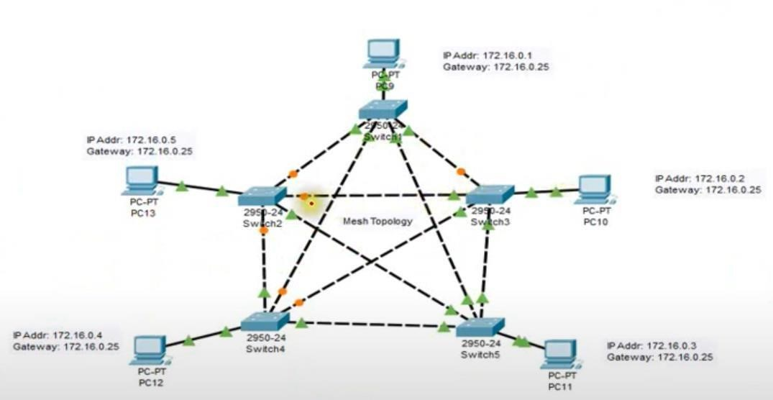

# Advantages of Mesh topology

1. Manages high amounts of traffic, because multiple devices can transmit data simultaneously.
2. A failure of one device does not cause a break in the network or transmission of data.
3. Adding additional devices does not disrupt data transmission between other devices.

# Disadvantages of Mesh topology

1.The cost to implement is higher than other network topologies, making it a less desirable option.

2.Building and maintaining the topology is difficult and time consuming

3. Scalability issues because a device cannot be connected with large number of devices with a dedicated point to point link.

# RING TOPOLOGY

In ring topology each device is connected with the two devices on either side of it. There are two dedicated point to point links a device has with the devices on the either side of it. This structure forms a ring thus it is known as ring topology. If a device wants to send data to another device then it sends the data in one direction, each device in ring topology has a repeater, if the received data is intended for other device then repeater forwards this data until the intended device receives it.

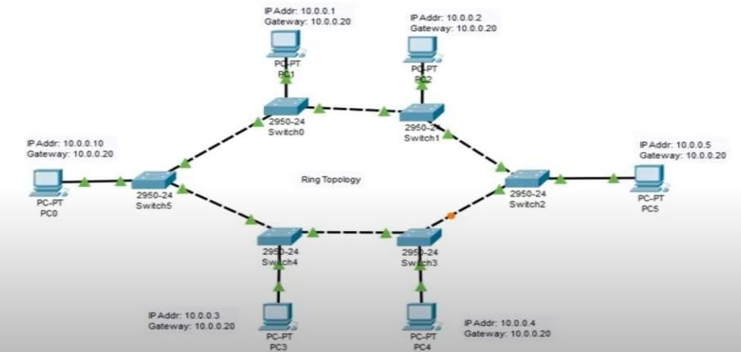

# Advantages of Ring Topology

1. Easy to install.
2. Managing is easier as to add or remove a device from the topology only two links are required to be changed.

# Disadvantages of Ring Topology

1. A link failure can fail the entire network as the signal will not travel forward due to failure.
2. Data traffic issues, since all the data is circulating in a ring

# DUAL-RING TOPOLOGY

Dual-ring topology is made up of two rings connected to a network. Each ring works independently until one is disabled when the network fails. When this takes place, the functioning ring automatically wraps around the disabled ring to ensure data flow.

# TREE TOPOLOGY

Tee Topology is a topology which is having a tree structure in which all the computer are connected like the branches which are connected with the tree. The main advantages of this topology are these are very flexible and also have better scalability. A tree topology is a special type of structure where many connected elements are arranged like the branches of a tree. For example, tree topologies are frequently used to organize the computers in a corporate network, or the information in a database.

Tree network topology is considered to be the simplest topology in all the topologies which is having only one route between any two nodes on the network. The pattern of connection resembles a tree in which all branches spring from one root hence (Tree Topology). Tree topology is one of the most popular among five network topology.

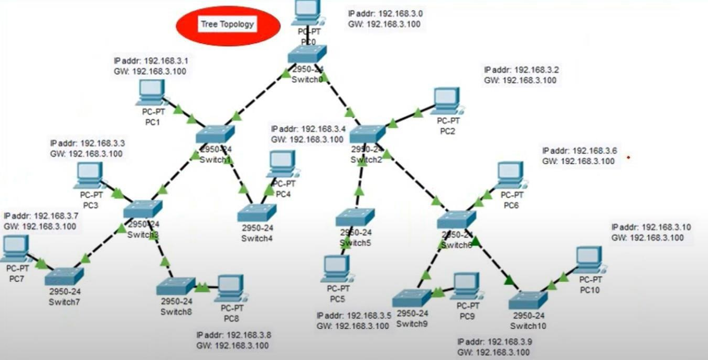

**Advantages of Tree Topology :**

This topology is the combination of bus and star topology.

This topology provides a hierarchical as well as central data arrangement of the nodes.

As the leaf nodes can add one or more nodes in the hierarchical chain, this topology provides high scalability.

The other nodes in a network are not affected, if one of their nodes get damaged or not working.

Tree topology provides easy maintenance and easy fault identification can be done.

**Disadvantages of Tree Topology :**

This network is very difficult to configure as compared to the other network topologies.

Length of a segment is limited & the limit of the segment depends on the type of cabling used

.Due to the presence of large number of nodes, the network performance of tree topology becomes a bit slowly.

If the computer in first level is erroneous, next level computer will also go under problems.

Requires large number of cables compared to star and ring topology.

As the data needs to travel from the central cable this creates dense network traffic.

# HYBRID TOPOLOGY

Hybrid topology is combination of two or more topology .. For example a combination of star and Bus topology is known as hybrid topology. The choice to use a hybrid topology over a standard topology depends on the needs of a business, school, or the users. The number of computers, their location, and desired network performance are all factors in the decision.

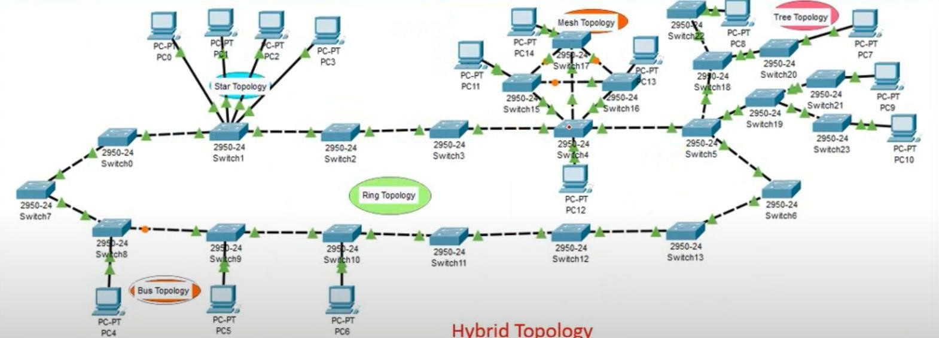

# Advantages of Hybrid topology

1. We can choose the topology based on the requirement for example, if scalability is the concern then use star topology instead of bus technology.

1. Scalable as we can further connect other computer networks with the existing networks with different topologies.

# Disadvantages of Hybrid topology

1. Installation and Fault detection is difficult.
2. Design is complex so maintenance is expensive.

**PROCEDURE**:

**1.**Connect devices in Packet Tracer window:

2.Give IP address, gateway address to PCs.

3.Simulate and observe results.

**DIAGRAM WITH SIMULATION:**

# 1A.SIMULATION DIAGRAM : BUS TOPOLOGY

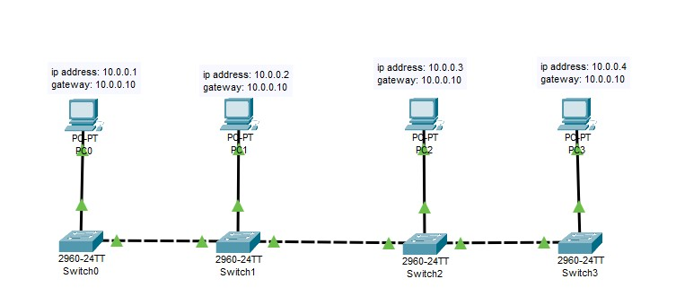

1B.PING RESPONSE : BUS TOPOLOGY

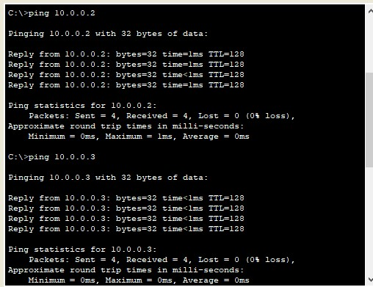

# 2A.SIMULATION DIAGRAM : STAR TOPOLOGY

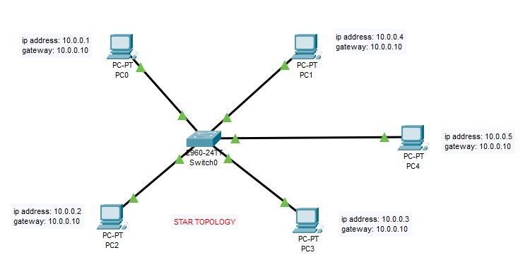

2B.PING RESPONSE : STAR TOPOLOGY

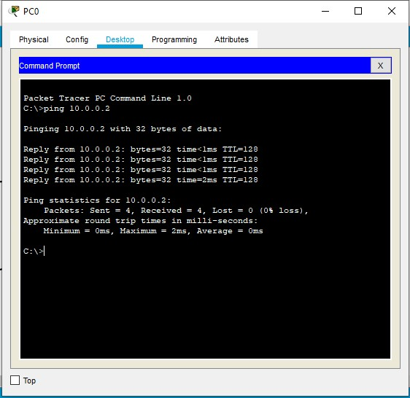

# 3A.SIMULATION DIAGRAM : MESH TOPOLOGY

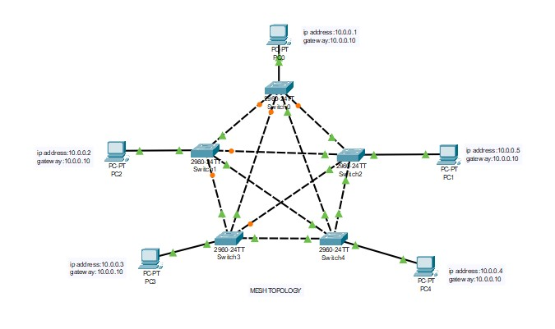

# 3B.PING RESPONSE : MESH TOPOLOGY



# 4A.SIMULATION DIAGRAM : RING TOPOLOGY

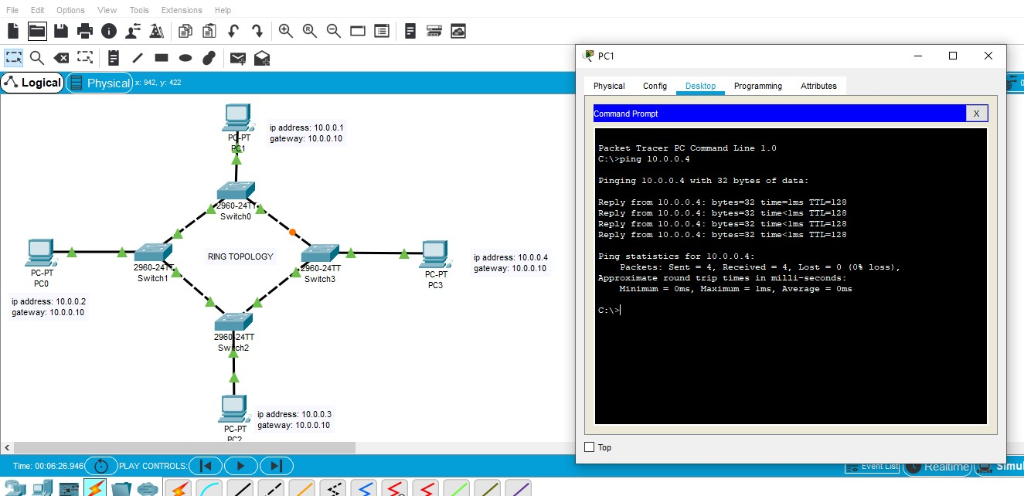

# 5A.SIMULATION DIAGRAM : TREE TOPOLOGY

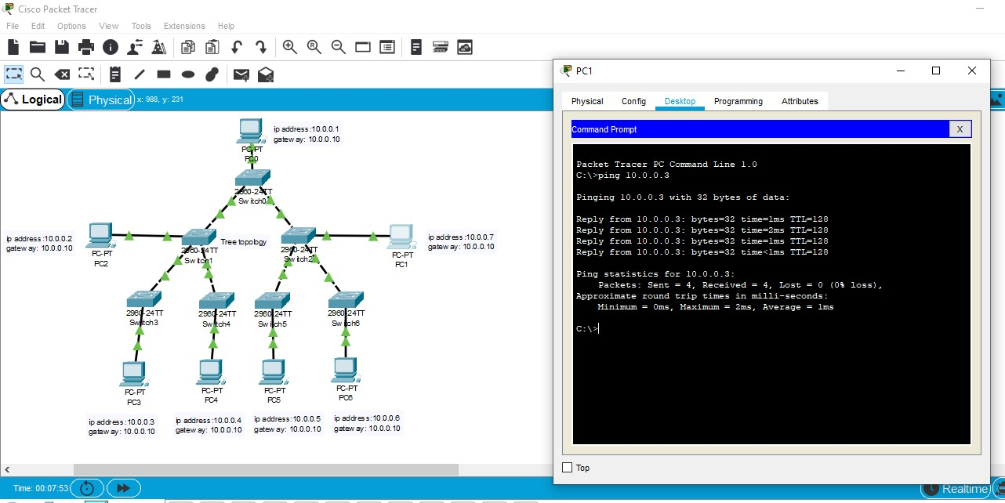

# 6A.SIMULATION DIAGRAM : HYBRID TOPOLOGY

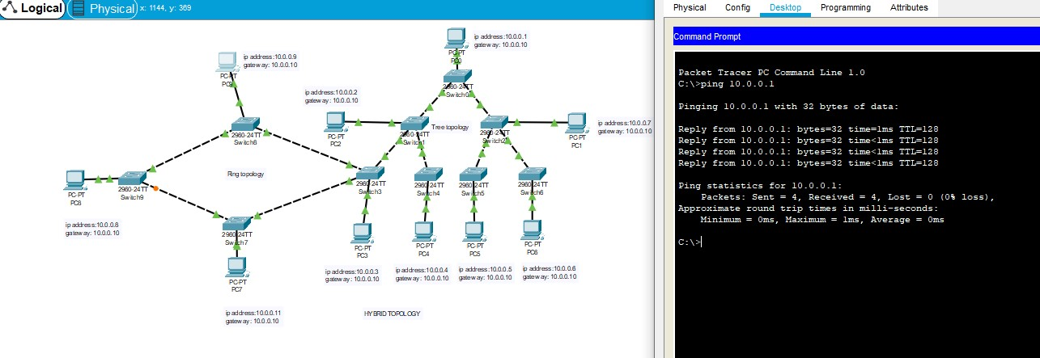

# 7A.SIMULATION DIAGRAM : DUAL RING TOPOLOGY



**7**



**B.PING RESPONSE : DUAL RING TOPOLOGY**

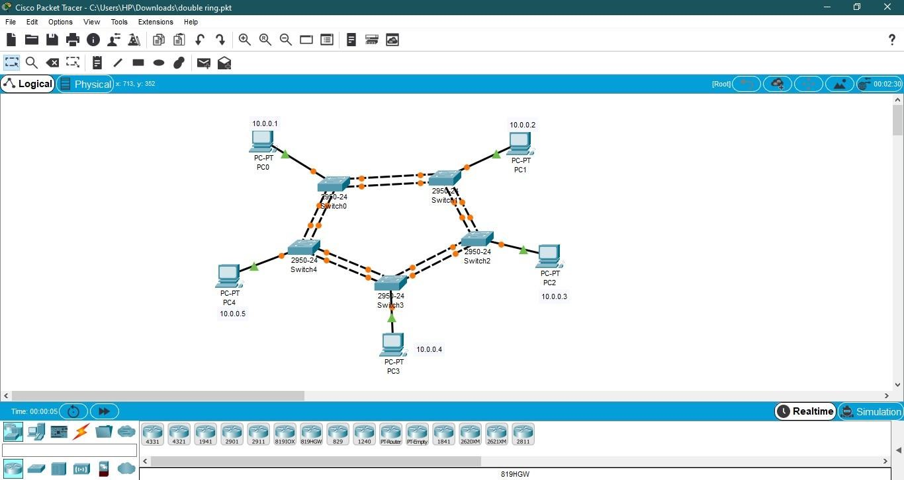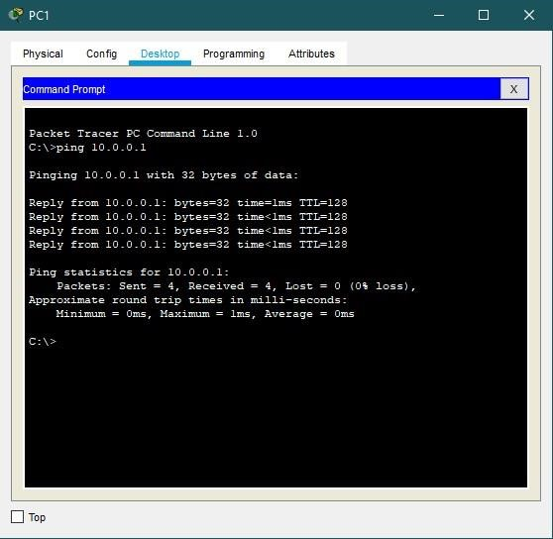

**CONCLUSION :**

We successfully studied & simulated various network topologies using Cisco Packet Tracer by assigning IP,Gateway & Subnet Mask Address to all topologies.We also studied & observed comparison of different topologies with respect to their parameters mentioned in the table.

Question :

**COMPARISON OF VARIOUS NETWORK TOPOLOGIES**

|  |  |  |  |
| --- | --- | --- | --- |
| Topology | Total No. Of Links | Privacy | I/O Lines |
| **1.MESH** | N(N-1) / 2 | Yes | N-1 |
| **2.STAR** | N | No | One |
| **3.BUS** | Single backbone with N drop lines | No | One |
| **4.RING** | N | No | One |
| **5.DUAL RING** | N | No | Two |
| **6.TREE** | N | No |  |
| **7.HYBRID** |  | No |  |

|  |  |  |  |  |  |
| --- | --- | --- | --- | --- | --- |
| TopologyInstallation & Reconnection | | Cost | Fault Identification | Line Application  Configuration | |
| **1.MESH** | Difficult | Expensive | Easy | Peer to Peer | Regional  Telephone  Offices |
| **2.STAR** | Easy | Less  Expensive | Easy | Peer To Peer | LANS,High Speed LANS |
| **3.BUS** | Difficult | Least  Expensive | Difficult | Multipoint | Not used in  Large  Networks |
| **4.RING** | Easy | Moderate | Easy | Multipoint | IBM Token  Ring |
| **5.DUAL**  **RING** | Easy | Expensive | Easy | Multipoint | IBM Token  Ring |
| **6.TREE** | Difficult | Expensive | Easy | Multipoint |  |
| **7.HYBRID** | Difficult | Expensive | Difficult | Multipoint |  |

